Student Roll # | @00677611
User ID | CHC119
Assessment Title | DBS Semester One Coursework
Module Title | Database Systems
CRN | 32741

ER Diagram:
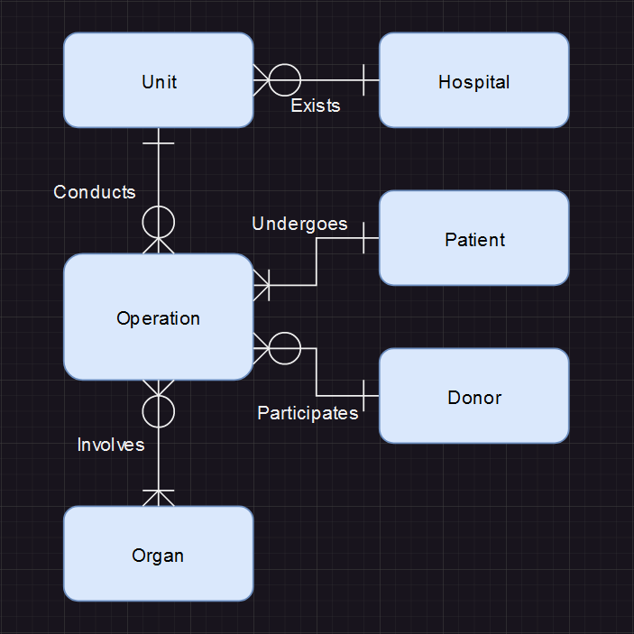

Logical Model:

Entities:
hospital( hospital_id, hospital_name, city, postcode )
transplant_unit( unit_id, hospital_id*, specialisation )
organ( organ_id, organ_type )
donor( donor_id, donor_name, age )
patient( nhs_id, paitent_name, age )
operation( operation_id, organ_id*, unit_id*, nhs_id*, donor_id* )

One-to-Many Relationship:
- One hospital can have 0, 1 or many transplant units. A unit must have a hospital. ( Hospital – Transplant Unit [1:M][m:o] )
- One unit can conduct 0, 1 or many operations. An operation must have a unit. ( Unit – Operation [1:M][o:m] )
- One patient must undergo 1 or multiple operations. An operation must have a patient. ( Patient – Operation [1:M][m:m] )
- One donor can participate in 0, 1 or many operations. An operation must have a donor ( Donor – Operation [1:M][m:o] )
Many-to-Many Relationship:
- Many operations can involve multiple organ types. An operation must have an organ, but an organ may not be used. ( Operation – Organ [M:M][o:m] )
Explanation of Normalisation:

1st Normal Form (1NF):
- Atomic Values
  - Every table has columns exclusively containing indivisible values.
  - There are no repeating groups or arrays within columns.

2nd Normal Form (2NF):
- Already in 1NF.
- No Partial Dependencies
  - Each non-key attribute is fully functionally dependent on the entire primary key.
  - In the hospital, transplant_unit, organ, donor, and patient tables, attributes are fully dependent on their respective primary keys ( hospital_id, unit_id, organ_id, donor_id, patient_id ).

3rd Normal Form (3NF):
- Already 2NF
- No Transitive Dependencies
  - There are no transitive dependencies between non-candidate attributes.
  - In the hospital table, city and postcode are functionally dependent on hospital_id ( primary key ). No transitive dependency exists between these attributes.

Statements for creating the Database relations:

( Kept to ISO standard as much as possible by using postgreSQL – foreign key constraints moved from inline )

CREATE TABLE hospital (
hospital_id CHAR(3) CONSTRAINT hID_pk PRIMARY KEY,
hospital_name VARCHAR(30) CONSTRAINT hospital_name_not_null NOT NULL,
city VARCHAR(15),
postcode VARCHAR(8) CONSTRAINT postcode_unique UNIQUE
);
CREATE TABLE transplant_unit (
unit_id CHAR(4) CONSTRAINT uID_pk PRIMARY KEY,
hospital_id CHAR(3),
specialisation VARCHAR(20),
CONSTRAINT hID_fk FOREIGN KEY ( hospital_id ) REFERENCES hospital( hospital_id )
);
CREATE TABLE organ (
organ_id CHAR(3) CONSTRAINT oID_pk PRIMARY KEY,
organ_type VARCHAR(15)
);
CREATE TABLE patient (
nhs_id CHAR(3) CONSTRAINT pID_pk PRIMARY KEY,
patient_name VARCHAR(10) CONSTRAINT patient_name_not_null NOT NULL,
age INTEGER
);
CREATE TABLE donor (
donor_id CHAR(3) CONSTRAINT dID_pk PRIMARY KEY,
donor_name VARCHAR(10) CONSTRAINT donor_name_not_null NOT NULL,
age INTEGER
);
CREATE TABLE operation (
operation_id CHAR(3),
organ_id CHAR(3),
unit_id CHAR(4),
nhs_id CHAR(3),
donor_id CHAR(3),
CONSTRAINT comp_op_key PRIMARY KEY ( operation_id, organ_id ),
CONSTRAINT oID_fk FOREIGN KEY ( organ_id ) REFERENCES organ( organ_id ),
CONSTRAINT uID_fk FOREIGN KEY ( unit_id ) REFERENCES transplant_unit( unit_id ),
CONSTRAINT pID_fk FOREIGN KEY ( nhs_id ) REFERENCES patient( nhs_id ),
CONSTRAINT dID_fk FOREIGN KEY ( donor_id ) REFERENCES donor( donor_id )
);

Statements for populating the Database:

INSERT INTO hospital
VALUES ('h01', 'Royal Infirmary', 'Manchester', 'M13 1AB'),
('h02', 'St James University Hospital', 'Leeds', 'LE6 6JX'),
('h03', 'Eye hospital', 'Manchester', 'M5 3AC'),
('h04', 'Wythenshawe Hospital', 'Manchester', 'M22 4XD');
INSERT INTO transplant_unit
VALUES ( 'u001', 'h01', 'Kidney (Renal)' ),
( 'u002', 'h02', 'Kidney (Renal)' ),
( 'u003', 'h01', 'Pancreas' ),
( 'u004', 'h02', 'Liver' ),
( 'u005', 'h04', 'Cardiothoracic' );
INSERT INTO organ
VALUES ( 'o1', 'kidney' ),
( 'o2', 'heart' ),
( 'o3', 'lung' ),
( 'o4', 'pancreas' ),
( 'o5', 'liver' );
INSERT INTO patient
VALUES ( 'p03', 'ben', 58 ),
( 'p04', 'jane', 27),
( 'p05', 'joan', 50);
INSERT INTO donor
VALUES ( 'd01', 'tom', 34 ),
( 'd02', 'dick', 45 ),
( 'd03', 'harry', 27 ),
( 'd04', 'sue', 60 ),
( 'd05', 'kate', 49 ),
( 'd06', 'rose', 34 );
INSERT INTO operation
VALUES ( 'op1', 'o1', 'u002', 'p03', 'd01' ),
( 'op2', 'o2', 'u005', 'p04', 'd02' ),
( 'op2', 'o3', 'u005', 'p04', 'd02' ),
( 'op3', 'o4', 'u003', 'p05', 'd03' ),
( 'op4', 'o5', 'u004', 'p05', 'd05' ),
( 'op5', 'o5', 'u002', 'p03', 'd01' );

Statements for querying the Database:

SELECT patient_name
FROM patient
WHERE age >= 50
ORDER BY patient_name;

SELECT organ_type, COUNT( organ_type )
FROM organ
INNER JOIN operation ON operation.organ_id = organ.organ_id
GROUP BY organ_type;

SELECT hospital_id, COUNT( hospital_id )
FROM transplant_unit
INNER JOIN operation ON transplant_unit.unit_id = operation.unit_id
GROUP BY hospital_id;

SELECT MAX( age ) AS oldest_donor
FROM donor
WHERE donor_id IN (
SELECT donor_id
FROM operation
WHERE unit_id IN (
SELECT unit_id
FROM transplant_unit
WHERE hospital_id IN (
SELECT hospital_id
FROM hospital
WHERE city LIKE '%Manchester%'
)
)
);

