Software Projects with Agile Techniques
CRN: 34129
Assignment 1
George Wilkinson
@00677611
CHC119
5/11/24

- Use case diagram.
- Two textual use cases.
- Simple system class diagram.
- References – the sources used in your report (and cite them in the body of your report). You must use the APA 7th Ed (Harvard) style.

Use Case Diagram

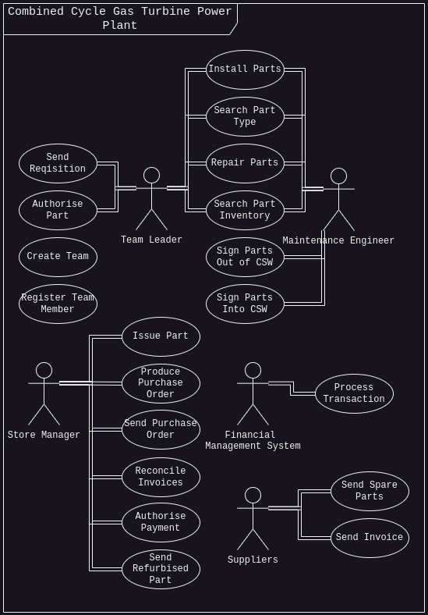

Textual Use Cases

References

Flowchart Maker & Online Diagram Software. (n.d.). App.diagrams.net; JGraph. https://draw.io

